SANSKAAR PATNI
180905134 CSE C-23 CD LAB 2

1. REMOVE SPACES AND TABS
#include<stdio.h>
#include <stdlib.h>
#include <string.h>
#include <ctype.h>

void removeSpaces(FILE* fa, FILE* fb)
{
char c1,c2;
while((c1=fgetc(fa))!=EOF)
{
if(c1==' ')
{
fputc(c1, fb);
while(c1==' ')
c1=fgetc(fa);
}
else if(c1=='\t')
{
fputc(' ', fb);
while(c1=='\t'){
c1=fgetc(fa);
}
}
fputc(c1,fb);
}
fclose(fa);
fclose(fb);
}

int main(int argc, char const *argv[]){
if(argc<3)
{
printf("Please specify the source and destination file-names as CLI argument\n");
exit(1);
}
FILE *fa,*fb;
fa=fopen(argv[1],"r");
if(fa==NULL){
printf("Cannot open file\n");
exit(0);
}
fb=fopen(argv[2],"w+");
removeSpaces(fa,fb);
return 0;
}
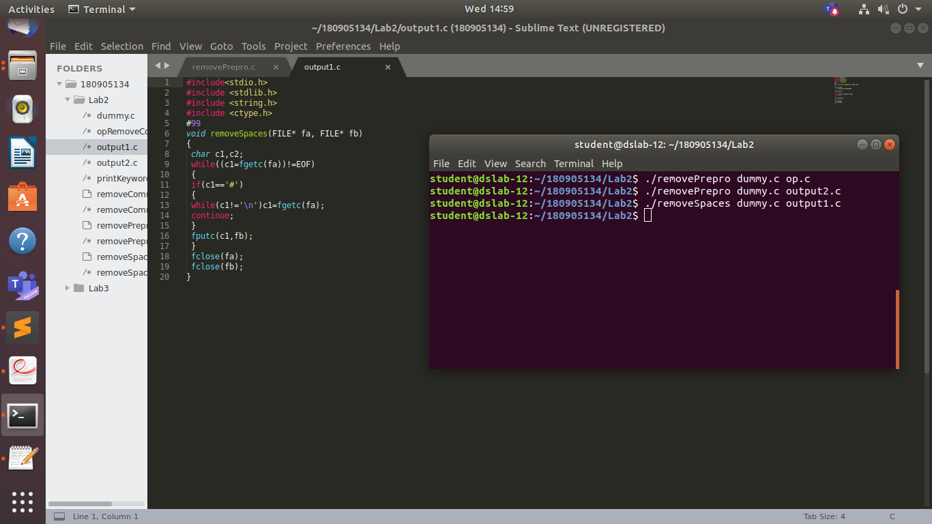
2. REMOVE PREPROCESSOR DIRECTIVES

#include<stdio.h>
#include <stdlib.h>
#include <string.h>
#include <ctype.h>
void removePrepro(FILE* fa, FILE* fb)
{
char c1,c2;
char buf[50];
int pos=0;
while((c1=fgetc(fa))!=EOF)
{
if (c1=='#')
{
int i=0;
pos=ftell(fa);
c2 = fgetc(fa);
while(isalpha(c2))
{
buf[i++]=c2;
c2 = fgetc(fa);
}
buf[i]='\0';
if(strcmp(buf,"include")==0 ||strcmp(buf,"define")==0||strcmp(buf,"undef")==0||strcmp(buf,"#ifdef"))
{
c2 = fgetc(fa);
while(c2!='\n')
{
c2 = fgetc(fa);
}
}
else
{
fputc(c1,fb);
fseek(fa,pos,SEEK_SET);
}
}
else fputc(c1,fb);
}
fclose(fa);
fclose(fb);
}

int main(int argc, char const *argv[]){
if(argc<3)
{
printf("Please specify the source and destination file-names as CLI argument\n");
exit(1);
}
FILE *fa,*fb;
fa=fopen(argv[1],"r");
if(fa==NULL){
printf("Cannot open file\n");
exit(0);
}
fb=fopen(argv[2],"w+");
removePrepro(fa,fb);
return 0;
}
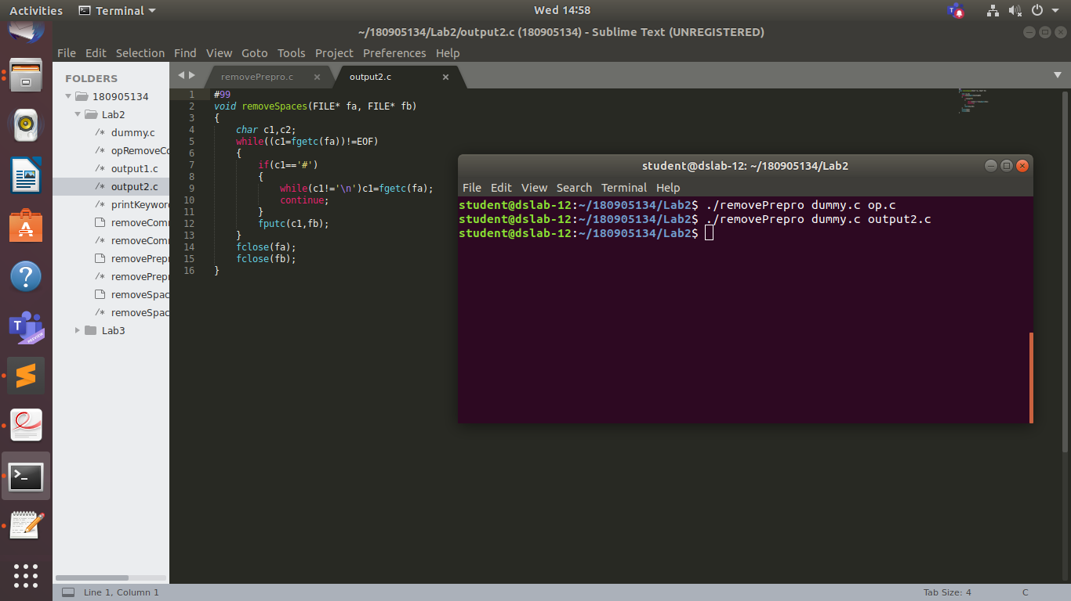
3. PRINT KEYWORDS
#include <stdio.h>
#include <stdlib.h>
#include <string.h>
#include <ctype.h>

void toUpperCase(char *str)
{
for(int i=0;i<=strlen(str);i++){
if(str[i]>=97&&str[i]<=122)
str[i]=str[i]-32;
}
}
void printKeywords(FILE* fa, FILE* fb)
{
char c1, c2;
char str[100]="";
// char temp[100]="#define";
char keywords[32][20]={
"auto", "break", "case", "char", "const", "continue", "default", "do", "double", "else", "enum", "extern", "float", "for", "goto", "if", "int", "long", "register", "return", "short", "signed", "sizeof", "static", "struct", "switch", "typedef", "union", "unsigned", "void", "volatile", "while"
};
int row=1,col=0;
while((c1=fgetc(fa))!=EOF)
{
col++;
if(c1=='\"')
{
fputc(c1, fb);
c1=fgetc(fa);
col++;
while(c1!='\"'&&c1!='\n')
{
fputc(c1, fb);
c1=fgetc(fa);
col++;
}
}
else if(c1=='\'')
{
fputc(c1, fb);
c1=fgetc(fa);
col++;
while(c1!='\''&&c1!='\n')
{
fputc(c1, fb);
c1=fgetc(fa);
col++;
}
}
else if(isalpha(c1))
{
fputc(c1, fb);
strncat(str, &c1, 1);
c1=fgetc(fa);
col++;
while(isalpha(c1))
{
fputc(c1, fb);
strncat(str, &c1, 1);
c1=fgetc(fa);
col++;
}
if(strlen(str)>0)
{
for(int i =0; i<32; i++)
{
if(strcmp(str, keywords[i])==0)
{
toUpperCase(str);
printf("Line %d Column %d %s\n",row,col-strlen(keywords[i]),str);
break;
}
}
str[0]='\0';
}
}
else if(c1=='\n'){row++;col=0;}
else str[0]='\0';
fputc(c1, fb);
}
fclose(fa);
fclose(fb);
}

int main(int argc, char const *argv[])
{
if(argc<3)
{
printf("Please specify the source and destination file-names as CLI argument\n");
exit(1);
}
FILE *fa, *fb;
fa = fopen(argv[1], "r");
if(fa==NULL)
{
printf("File ./%s does not exist\n", argv[1]);
exit(1);
}
fb = fopen(argv[2], "w+");
printKeywords(fa, fb);
return 0;
}
